ON Cassandra Expert Advisor

- Header Section, and Input Parameters

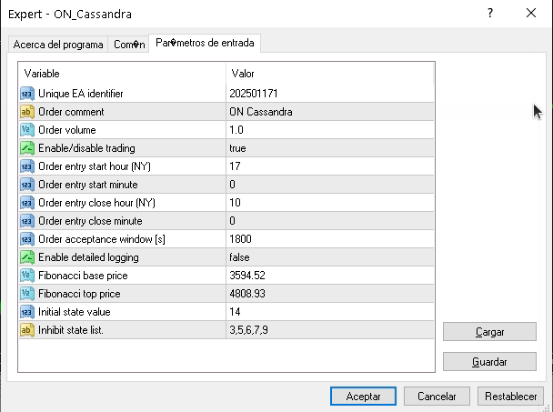

The above window shows all the hyperparameters for the configuration of the ON expert advisor.
Next is a concise explanation of them:
- MagicNumber (202501171)
Unique identifier for EA-generated orders (prevents interference with manual trades).
- Comment ("ON Cassandra")
Text label attached to all orders created by this EA.
- LotSize (1.0)
Trade size in standard lots (1.0 = 100,000 units).
- ContinueTrading (true)
Master switch: false = stops new trades while keeping existing positions.
- OpenTimeHour (17) + OpenTimeMinute (0)
Trading session start: 17:00 NY = 5 PM Eastern Time.
- CloseTimeHour (10) + CloseTimeMinute (00)
Position closure time: 10:00 AM NY (next GMT day).
- TimeToleranceWindow (1800)
Execution window duration: 30 minutes after session start.
- Verbose (false)
Detailed logging toggle: true = shows price/state updates.
- nbi (3594.52) + nti (4808.93)
Fibonacci baseline: nbi = support base, nti = resistance peak.
- Zin (14)
Initial market state: Numerical representation of price position relative to Fibonacci levels.
- Vstr ("3,5,6,7,9")
Blocked states: When Z matches any listed number, trading is suspended.

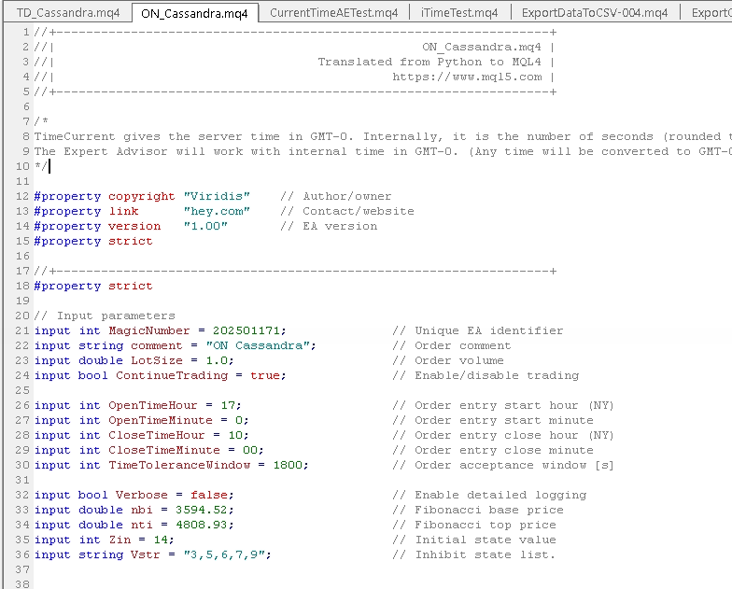

- Core Functionality Overview
  - Time Management
    - Server Time Handling: Uses GMT-0 time internally
    - New York Time Conversion
    - DST Handling: Automatically adjusts for Daylight Saving Time. It uses `IsNewYorkDST()` to determine DST period
  - Trading Session Logic
    - Entry Condition:
if (CurrentTime >= openTimeGMT0Lb && CurrentTime < openTimeGMT0Ub
&& !PositionOpen && !IsZInV(Z, V) && ContinueTrading)
    - Exit Conditions:
else if (CurrentTime >= closeTimeGMT0Lb && PositionOpen)
  - Fibonacci System
    - Key Levels
    - Visualization
  - State Management
    - Zone Tracking:
Maintains `Z` state based on price vs Fibonacci levels
Inhibited states (`V`) prevent trading when active
    - State Transition:

- Key Functions Summary

Function | Purpose
CalculateFibonacciLevels | Computes and draws Fibonacci retracement/extension levels
SetTradingTimes | Calculates valid trading windows in GMT-0
IsNewYorkDST | Determines Daylight Saving Time status for New York
UpdateFiboZone | Tracks market structure changes at 16:00 NY time
ParseInputString | Converts Vstr input to integer array

- Notes
  - Time Zone Handling
    - All internal calculations use GMT-0
    - Automatic DST adjustment for New York time
    - Trading windows converted to broker/server time
  - State Transition Logic
    - 16 possible states (Z values)
    - State changes trigger at Fibonacci level crossings
    - Inhibited states prevent trade execution
  - Session Management
    - Default entry window: 17:00-17:30 NY time (GMT-0 converted)
    - Default exit window: 10:00-10:30 NY time (next day GMT-0)

